Tourists or Pigs
Ronan Le Coadic interviewed by Sharif Gemie
Ronan Le Coadic is one of Brittany's leading sociologists. His most substantial work to date is L'Identité bretonne published in 1998. His work is distinctive: on the one hand, one senses in his books and essays the deep love which he feels for his country. On the other, he writes no sentimental, "green, green grass of home" tear-jerker. Throughout his work, there is a tough, realistic tone, which demands that intuitions be verified and evidence checked. The final result is a convincing, impressive synthesis of ideas, ideals and data.
For this interview, we started by reviewing some statistics Le Coadic had collected on Breton public opinion, but soon moved on to discuss the nature of Breton nationalism.
Your data suggests that half of the Breton population would like to live in a village.
Sharif Gemie lectures in Modem European History at the University of Glamorgan. He is currently writing a book on Breton iden-tity.
This isnt't specific to Brittany. Across France, people dream of living in the countryside — but they never get there. People in the big cities want to live in a small town, and people in small towns want to live in a village: they all think that where they live is too crowded too noisy. Sometimes you see one or two people moving out of the big cities to live in the country, in the centre of Brittany. What do they do there? They are lost, completely lost! It was just a dream. They choose their place, and then many of them go on to somewhere else.
In a few villages, the néo-ruraux, the back-to-the-landers of the late 1960s and early 1970s, have survived and even form the major-ity of the population. They do things like pottery, they live together. They create something new, but their relations with the local people are not always good.
And then there are the British tourists who come ta stay.

64 Tourists or Pigs

Interview with Ronan Le Coadic 65
was presented as being without a cultural dimension, entirely civic, entirely political — a choice to be made. Through the social contract you chose to belong to the French nation. All quite different from the basis of the German nation.
But, in reality, this nation was based on a single culture which was imposed on everybody. The ideas of citizenship, of liberty, of the nation were all linked to the French culture, and this led Bretons to think to themselves: "What are we? Sub-human?" During the late nineteenth century and early twentieth century there was a flood of writing which compared the Bretons to pigs: the Bretons were dirty, unwashed. The Bretons suffered all this, and then tried to leave behind their language, their identity, and even their distinctive clothes. A lot of people even threw out their old furniture, or gave it away, or burnt it.
Then in the late twentieth century there was this widespread trend which Anthony Smith terms "the ethnic revival". Here, the young went in quite the opposite direction from their parents. But this was purely a cultural or even an emotional movement. The Bretons began to say "We're not that dirty, we're not sub-human, we have our own pride". Sometimes this was linked to an intellectual analysis, an attempt to analyse oneself, but as for political projects — nothing at all! Among the population it was something simply emotional. People began to give Breton names to their children, to drink chouchenn [a near legendary apple-based liqueur, approxi-mately equivalent to the Irish poteen] to listen to music by Alan Stivell, but nothing more.
And to give their houses a new name: Ty-something.
Yes, all that. But all these activities were something that you could do while still living within what you might call the traditional French model. On the other hand, thinking about yourself, devel-oping a rational argument, that would have demanded a clean break. It was a break which the Bretons never managed to make. I think that they were scared. I think they were saying: "Within me, there's probably not a pig, but there might be a monster". They re-mained convinced that Breton-ness is dangerous. Those hostile images from the late nineteenth century and early twentieth century remained very powerful. Then there was also the record of the handful of Bretons who collaborated with the Nazis during the Second World War, and the political violence of the 1970s. And all this meant that devising a political strategy for Brittany appeared an extremely dangerous option
And so… Your typical Breton is extremely French during the day and then, in the evenings, once they've drunk a glass or two too many, they begin to say things that are absolutely incredible. I'm not talking about people who are in the Breton nationalist movements,
No, not British, more often just English. In the first generation, a lot of them tried to adapt: they learnt French, a few of them learnt Breton, and they tried to build up relationships with local people, they went to the bars to drink with them. Now it is changing: more and more they just live together, they don't try to learn French at all. I met one old English woman who had lived in Brittany for thirty years and who didn't know one word of French. This is more and more common. They have their own networks to buy houses, and they live by themselves.
How do tourists affect the countryside?
A comment that you hear is "either tourists or pigs". I've heard people say "there are too many farmers, the tourists don't like them". The policy seems to be to present either unspoilt nature or a pretty garden, and to hide the farmers away, so that the tourists will come and spend their money.
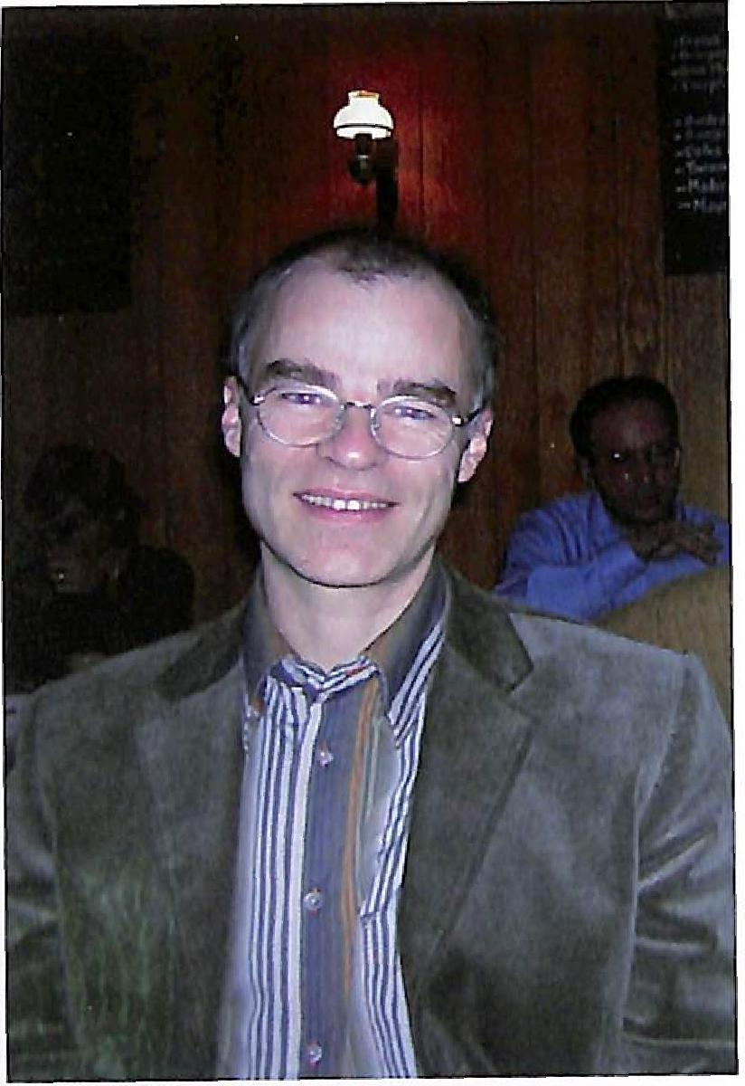
The farmers are dreadfully worried. They say "we can't see a future, we're lost". Many of them are right-wing rather than left-wing, and they're worried about what the new left-wing majority in the Breton regional administration (the Breton equivalent of the Welsh Assem-bly) will do. Organic farming may be a good idea, but it simply isn't possible for everyone to become an organic farmer.
And what of the Breton autonomists or na-tionalists? Where are their strengths? What does the future hold for them?
A good question! (He laughs) Well, it has to be asked.
You see... It's hard to answer that question in a couple of sentences. The argument that I present in Le fruit défendu (Forbidden Fruit) is that the Bretons suffer from an inferior-ity complex, linked in part to the processes which form an identity. These always require a dialogue: an identity can't be created by it- self; it's always in relationship with other identities. The important identity here has been the French identity, and that was created by a discourse which doesn't respond to reality. It was an identity which
Ronan Le Coadic.

66 Tourists or Pigs
I'm talking about ordinary workers and farmers who in the bars in the evening will say things that are more extreme than the most radical of the Breton nationalists. But they'll only say such things in certain contexts: they don't dare reflect on what it means to be Breton.
What do the Bretons want to do with their society? They don't dare ask themselves that question. They won't break with the political consensus. They don't think about either the economy or the political future.
And so, the Breton nationalists are people who've been woken up. Something happens, all of a sudden: perhaps they meet someone, perhaps they move out of Brittany, and they say "Ah, I'm Breton", and they start to think about it. They read a lot, they begin to frequent certain places, they do a course in the Breton language, and then they have an extremely coherent culture, they're extremely well-informed about Brittany. But to understand them, you have to be in the same goldfish bowl. They don't know how to communicate to people who haven't made the journey. The Bretons who haven't read all those books, who haven't gone to university to study the history of Brittany, can't understand them at all.
But what about Stivell, Glenmor, the Tri Yann and Servat? These are all singers who, in a way, have expressed the ideals of Breton nationalism, and they've been extremely popular.
Exactly, they've had a great impact on the population. But only within the fields of the emotions and culture. What's needed is a political strategy, and for this it's essential that the politicians are able to talk to and with the people, to use the same language. Take, for example, the farmers who are going through a terrible crisis. Which politician is capable of talking with them?
It seems to me that the nationalists are stuck in their logic, which is perfectly coherent, not absurd at all, but which is very far from the daily concerns of the population at large. And the people never manage to take that step, to think about themselves.
Lastly, there are no intellectuals. The Breton universities don't of-fer courses on today's Brittany. There are some very interesting works on the history of Brittany, on the Breton language, on ethnol-ogy, lots on the past: but on the present, there's nothing.
Is the blocking of Breton nationalism linked to the strength of Catholicism in the region?
It is linked, but not in the way you're suggesting. Religious practice is in decline, and this is one factor which is vital for the formation of Breton nationalism. You can see that in Catalunya, in the Basque Country — and even in France itself! While the immense majority of Breton people will still say "I'm Catholic", the numbers who attend
Interview with Ronan Le Coadic 67
church every Sunday are a tiny minority.
In its place, you can see "para-religious" rituals developing, such as the pardons (local pilgrimages to particular religious sites) or the Tro Breizh (walking tours to each of the nine old bishoprics of pre-1789 Brittany). People say "Oh, I do that because the people are so friendly", but there is still a real religious dimension to such prac-tices. All the same, they're only followed by a minority of people.
What concerns the majority of the population is the legacy of re-ligious practice: its values. These have a considerable influence. Everything here is marked by Christianity. Ouest-France, our main daily paper, is a Christian paper. The Socialist Party in Brittany is dominated by Rocard's tendency — a Christian tendency. The biggest trade union federation in Brittany is the CFDT (The French Confederation of Labour), which was originally a Christian confed-eration. The biggest bank in Brittany is the Crédit Mutuel de Bretagne, which was created by priests. Even in Breton commerce, there is — now and again — a certain Christian ideal, a certain solidarity. If one firm has an accident, then the competitors will hold back from poaching its customers. This isn't "normal" capitalism, red in tooth and claw. These values also work to hold back the worrying advance of the far-right Front National: in Brittany, the FN usually gets less than half the level of support that it wins elsewhere in France.
I wonder if the type of Breton nationalism that developed in the 1980s might one day provide a similar form of social structuring like that which was provided by the Church.
Further reading: Ronan Le Coadic, L’Identité Bretonne (Rennes: Terre de Brume/Presses Universitaires de Rennes, 1998); Bretagne: Le fruit défendu (Rennes: Presses Universitaires de Rennes, 2002); “Ce que veulent les Bretons”, Ouest-France, (29 June 2003); La Bre-tagne dans vingt ans, (Brest: Éditions Le Télégramme, 2004).

